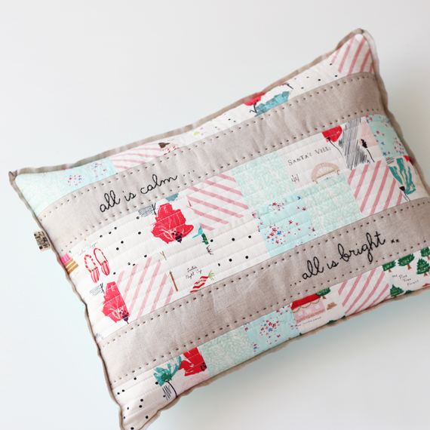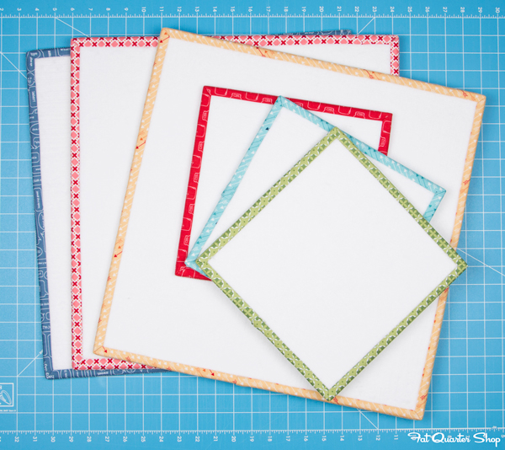
All Is Calm Pillow or Wall Hanging: Mini Project Boards:
About a fat quarter’s worth of 2 1 /2” holiday prints Foam core board 20” x 30” (Hobby Lobby)
About ¾ yd. of solid fabric * you can cut to size you would like
Embroidery floss & fiberfill Batting
Optional- trim A variety of 2 ½” strips

Giant Scrappy Swoon Star

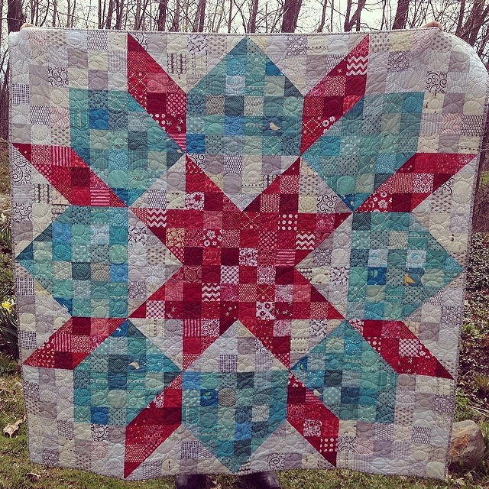

Fabric Requirements and Cutting Instructions
- These are minimum amounts needed; the scrappier the better!
Background fabrics
9 FQ’s cut into
42 – 3 7/8 inch sq’s & 192 – 3.5 inch sq’s
Primary color (the center star color)
7 FQ’s cut into
36 – 3 7/8 inch sq’s & 132 – 3.5 inch sq’s
Secondary color (the outer ring)
8 FQ’s cut into
30 – 3 7/8 inch sq’s & 168 – 3.5 inch sq’s
The quilt will finish at 72 inches square

Example of cutting: each FQ will yield 24, 3 ½” sq’s & 5, 3 7/8” sq’s with careful cutting!

